List of Top Entrance Exams after Class 12th

Most of you may be tangled on “what’s next” to graduate after finishing primary education. Do you think after studying NCERT textbooks along with so many reference books, you are left with only limited options to graduate in fields like commerce, science or humanities as common career options after 12th .
We bring you a compiled list of entrance exams for unconventional and conventional UG jobs and courses after class 12. Most of the entrance exams and courses mentioned below are based on National Level competitive exams.

Engineering Entrance Exams
JEE Main
This is one of the entrance exams based on National level which is conducted for Engineering course by the CBSE board (Central Board of Secondary Education). The exam forms a path to get entry into IIITs, NITs and institutions funded centrally such as IIST and the eligibility exam to attempt JEE Advanced.

BITSAT
BITSAT (Birla Institute of Technology and Science Admission Test) is conducted for entry into different engineering courses at BITS campuses in Goa, Hyderabad and Pilani. This is an online exam for gateway to BITS Pilani Engineering, Information Systems, and Pharmacy. Notification is declared in December and exams are conducted online in May.
Vellore Institute of Technology Engineering Entrance Test
VITEEE (Vellore Institute of Technology Engineering Entrance Test) is conducted for admission to its different B Tech courses. The online forms will be out from December for all the aspirants and exam to be held in March.

Medical Entrance Tests

National Eligibility Entrance Exam for Undergraduate
NEET - Under Graduate is an All India entrance eligibility exam for admissions in BDS/MBBS courses after XII standard Science.

All India Institute of Medical Sciences
The AIIMS organizes an entrance test for admission for seats in MBBS, AIIMS New Delhi along with six other new institutions like AIIMS.

Armed Forces Medical College Entrance Exam
AFMC Exam is considered to be one of the most difficult entrance exams tests after class 12th exams. The course duration is 4 and half years with complete 1 year internship. It is mandatory to serve for at least 7 years as a commissioned officer in medical services after AFMC entrance exam is qualified.

Marine and Defence
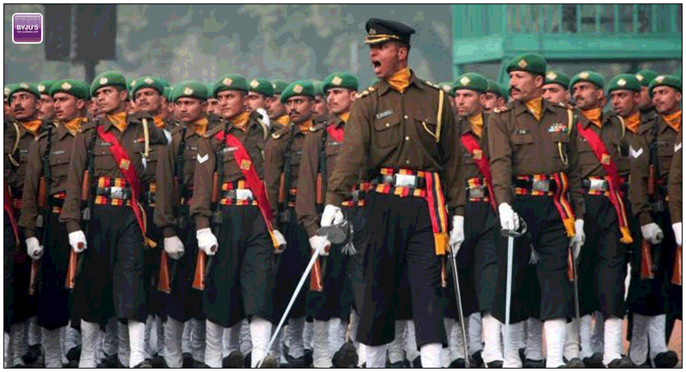

National Defence Academy Exams
These are the entrance exams for the one who choose to join defence force. The aspirant can join Air Force, Army and Navy after qualifying the NDA based on their passing aggregate in training period.

Indian Navy B.Tech Entry Scheme
This is an entrance exam for students seeking admission to B.Tech courses in the Indian Navy.
Indian Maritime University Common Entrance Test
This is an entrance exam for those who opt for admission to Diploma in Nautical Science after 12th Class having Science stream. The shortlisted aspirants are provided a BSc degree in Nautical Science.
Indian Army Technical Entry Scheme
Technical Entry Scheme is conducted for the students who belong to PCM background.
Indian Navy Sailors Recruitment
This is another recruitment exam for candidates with subjects Mathematics along with Chemistry/Physics/Biology who get training at INS Chilka.

Design Entrance Tests

NIFT entrance test
The National Institute of Fashion Technology conducts an entrance exam for admission its program for bachelors. It takes CAT and GAT and situation test. You need to appear for GAT test or admission to B.F Tech.
All India Entrance Examination for Design
The AIEED is conducted for the candidates who opt for admission in 4 years UG programmes in design.
NID
The National Institute of Design conducts Design Aptitude Test to its undergraduate at every centres for admission. The test is conducted in the month of January and applications are closed in the month of November. The specified age limit to register for the exam is 20 years.

The above courses include the most opted and preferred exams after class 12th in every stream, apart from many other better alternatives which are not mentioned in the list. You need to love what you do as your job is what that matter’s the most.

Author -
Amit Paliwal believes in the impact of writing along with developing articles, blogs and notifications. According to him, every word is an ornament of every content and language is the most powerful means of knowledge that can only be achieved through effective writing. Apart from content writing, music, painting and sports are his field of interest. Email- amit.paliwal@byjus.com.

********************

